**Project 1**

The next step, we have to import this CSV file into Pandas library. Pandas is a powerful data analysis library providing flexible way to do data manipulation. There are many mathematical and scientific computational features can be leveraged using this library. Let us see some of the features in our exercise.

In order to load the CSV file using Pandas, we need to do the following step.

Image for post

Pandas returns as Data frame object. Using data frame object, we can see the top 5 rows using “head()” function and “tail()” function to display last 5 rows in a CSV file. In our above example, we have used “df.head()”, it displays first 5 rows in the loaded CSV.

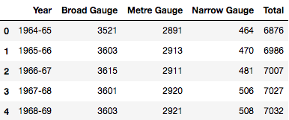

Below are some of the essential Pandas functions and attributes.

* iloc [ ] — is primarily an integer based location search — iloc[3]
* loc[] — is primarily a label based location search — loc[‘Broad Gauge’]
* idxmax()- is a function to identify the index of first occurrence of maximum over request axis.

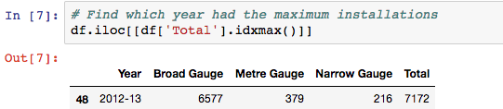

Using idxmax() function

Data Visualisation

Using Matplotlib or Seaborn, we can plot the data flow in graphical representation format. In our example, below steps are used to see the data using bar chart.

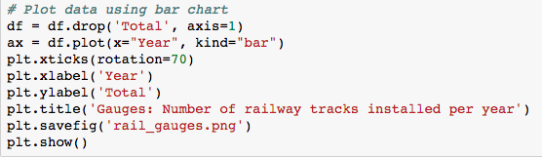

And the output graph look likes in below.

